GAMMA INTERNATIONAL COLLEGE
KG1 Supply List
Please label each item in the supplies with the student's name and send them in a large plastic box .
🧸 Item | 🔢 Quantity | 🖼️ Image
Pencils ( Faber castell HB) | 3
Erasers (Faber castell) | 3
Sharpeners | 2
Bottles of  Kouratol or  Primo liquid  gouache color | 3 | 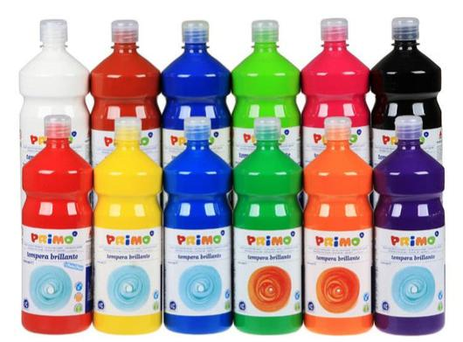  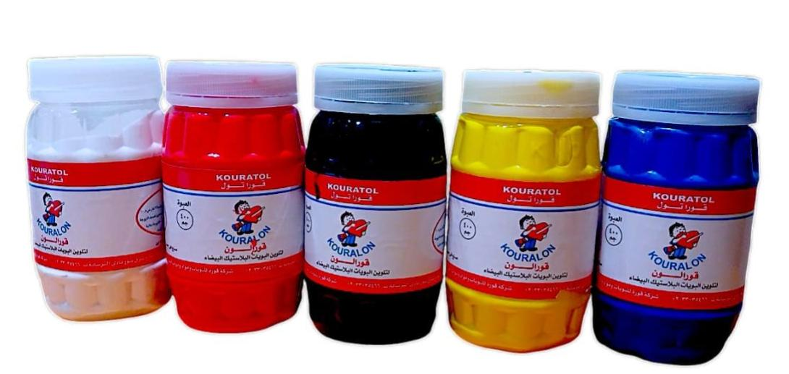
Apron with long sleeves | 1
Spare outfit | 1
Sponges set | 1 pack | 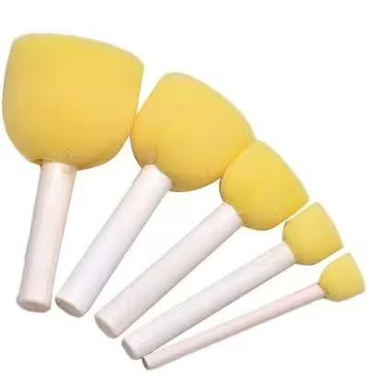
Small glue sticks | 10
Display file with 200 sheets | 1 | 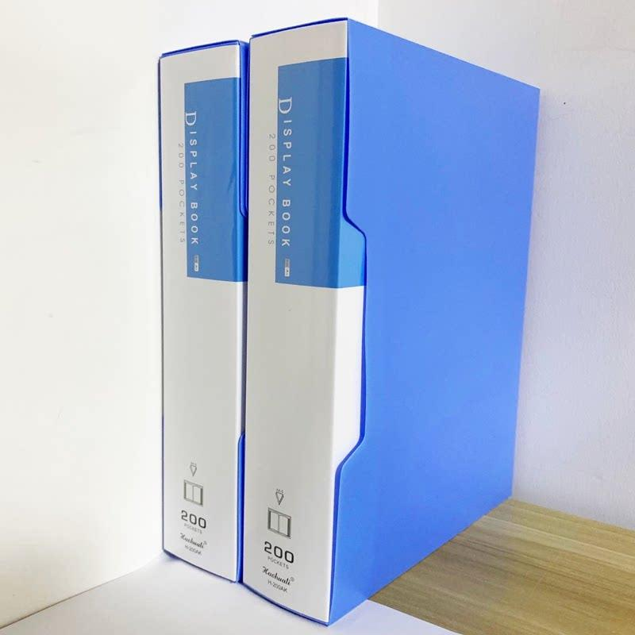
U shaped files | 1 pack
Zipped file/ big size | 3 ( 2 red and 1 blue ) | 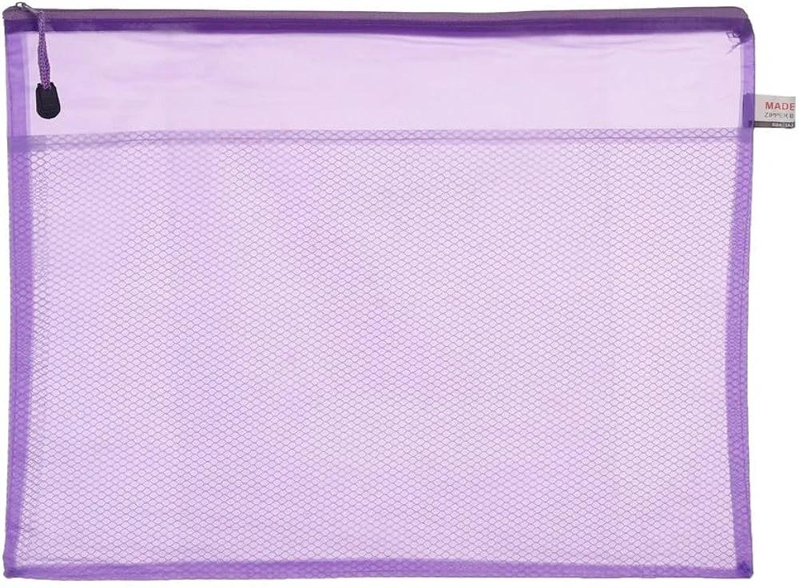
Play dough | 3 packs
Googly eyes | 1 pack
Mini white board | 1
White board marker | 1
White board duster | 1
Paint brushes | 1 set | 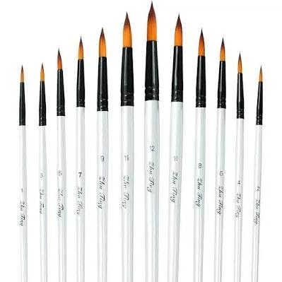
Wooden Color  pencils ( big size ) | 1 Pack | 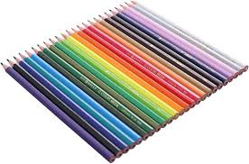
Foam glitter A4 | 2 packs | 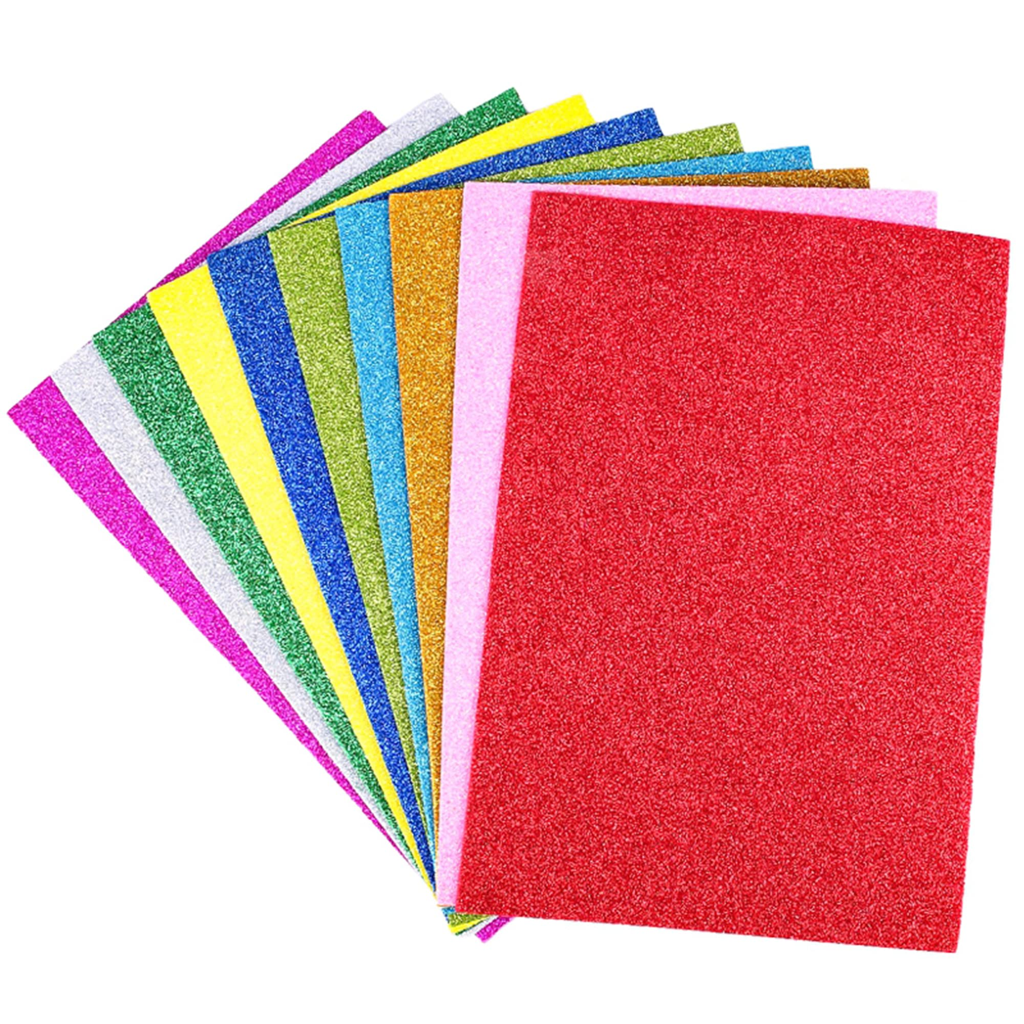
Regular foam A4 ( non glitter) | 1 pack
Canson sheet big size | 1 | 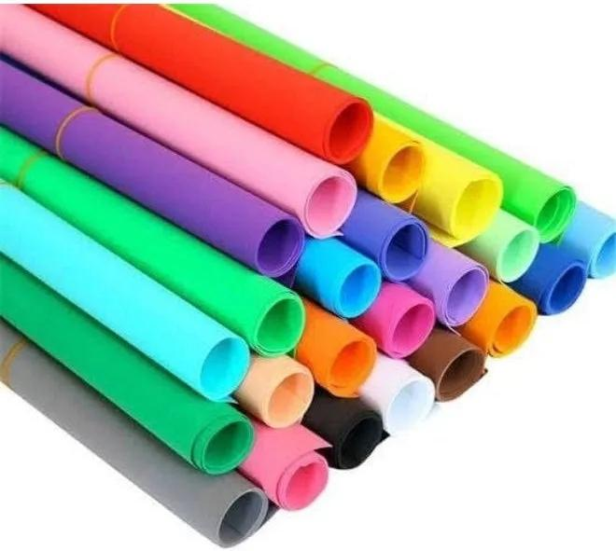
Foam glitter big size | 2 different colors | 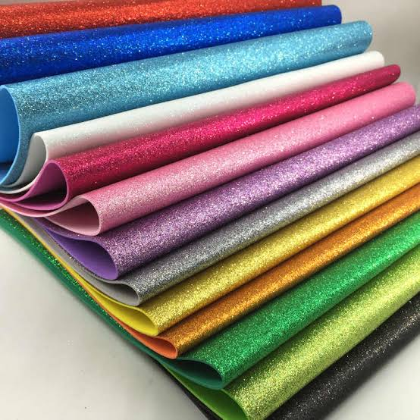
White sketch | 1 | 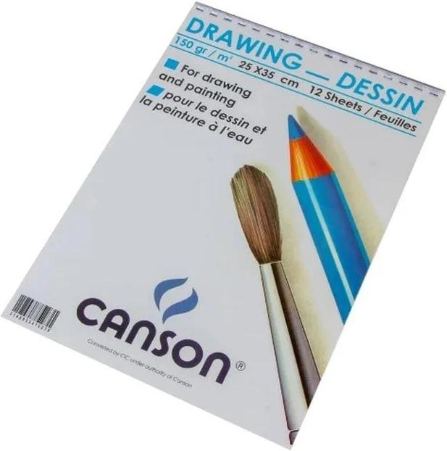
Colored sketch | 3 | 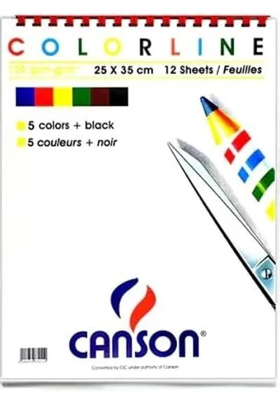
Safe scissors (metal and good quality) | 1 | 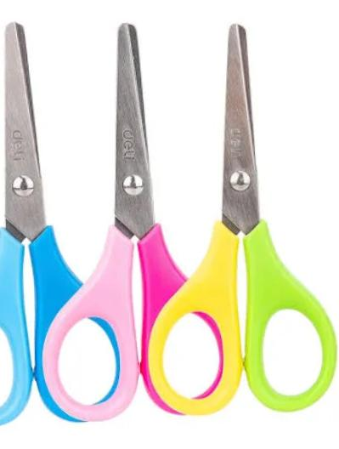
A4 white papers | 1 pack
A4 colored papers | 1 pack
Pipe cleaners | 2 packs
White foam round plates | 1 pack | 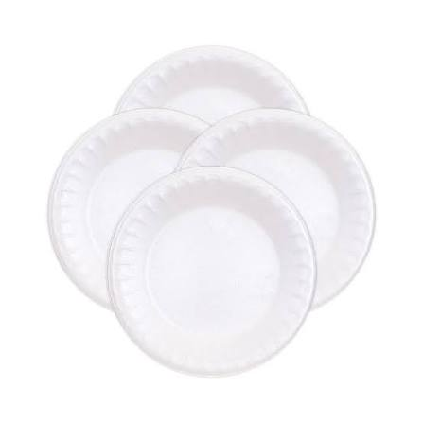
White foam cups | 1 pack | 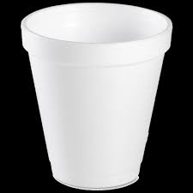
Plastic forks | 10
Plastic spoons | 10
Satin ribbon | 1
Yarn | 1 yellow and 1 any other color | 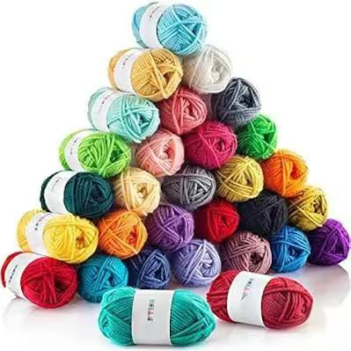
Wooden Tongue depressor | 1 pack
Alcohol 70 % | 2 bottles 100ml
Tissues (550) | 4 packs
Wipes (80) | 4 packs

