 | Essential classroom Item | Quantity
 | Pencil case With a zipper | 1
 | 2B Pencils | 1 pack of 12
 | Erasers (Faber Castle) | 3
 | Sharpeners | 2
 | Wooden colored pencils (good quality) | 1 pack of 12
 | Good quality wax crayons | 1 pack of 12
 | 6 white board markers | 3 blue, 3 black
 | 1 Large, 9 Small glue sticks (good quality) | 10
 | Metal scissor of good quality (rounded edge) | 1
 | Jumbo pencil | 1
 | Jumbo sharpener | 1
 | Good quality white board (A4 size) | 1
 | Whiteboard duster | 1
 | Clip board ( standard) | 1
 | 1 Ring binder Capacity ( 175 or 200 sheet),  1 Ring binder Capacity ( 50 sheets) | 2
 | U-shape files (100 sheets) | 1 pack
 | A3 size Zip files ( Blue and Red) | 2
 | A4 colored canson sheets | 3 packs of 10
 | A4 colored paper (100 Sheets) | 2 packs of 100
 | A4 white paper | 1 pack
 | Colored sticky notes ( 4*4 inch) | 1 pack
 | A4 Math copybook (big squares) | 1 ( 40\ 60 pages)
 | A4 English lines copybook ( 2 or 4 lines with wide space) 🙂 | 1 ( 40\ 60 pages)
 | Arabic Copybook ( 9 Lines) | 1
 | Pompoms | 2 Packs
 | Plastic plates | 1 Pack of 5
 | Google eyes | 1 Pack
 | Tongue depressors | 1 Pack
 | Pipe cleaners | 1 pack of 10
 | Bingo play dough (different colors) | 3 packs
 | Finger paint | 1 set
 | 3 Small Paint color bottles (Red, blue, yellow) | 1 from each color
 | Paint brush size “12” | 1
34. | Apron with long sleeves | 1
Hygiene
 | Packs of tissue (550 sheet) | 3 packs
 | Wipes ( 200 sheet ) | 2 packs
Art supplies
 | White canson sketch size A4 | 1
 | Colored canson sketch size A4 | 1
 | Pencil colors (24 pencils) | 1
 | Flow master colors (24 pencils) | 1
5. | Small metal scissor ( Rounded edge) | 1
6. | White glue | 1
7. | Foam play dough | 1 Pack
8. | Tongue depressors | 1 Pack
9. | Paint brushes | Size 4 and 8
10. | String rollers any color | 2
11. | Canva 25*30 | 1
12. | Zipper file | 1
Pencil case containing (pencils, eraser sharpener, large glue stick, black permanent marker)
- All supplies must be labeled with the child’s name.
- All art supplies should be placed in the zip file.

Metal Rounded edge scissor | English 4 lines with colored lines | English 2 lines with wide spaces
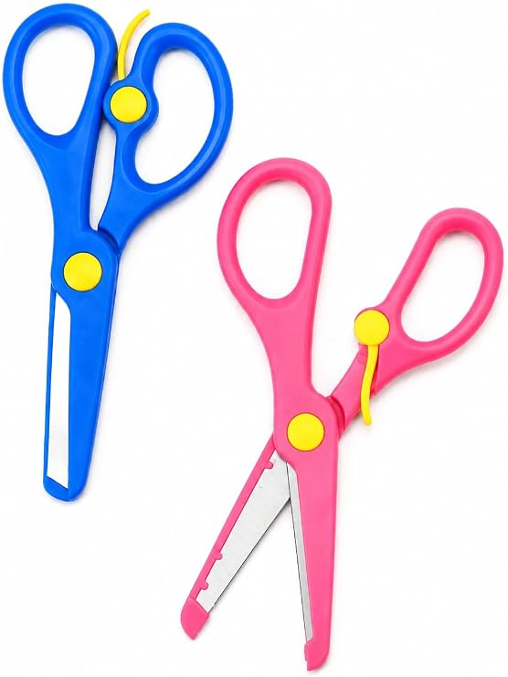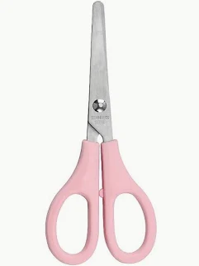 | 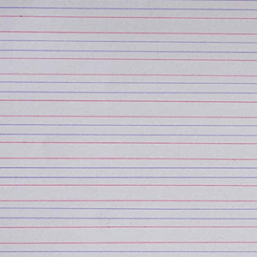 | 