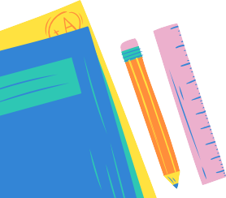
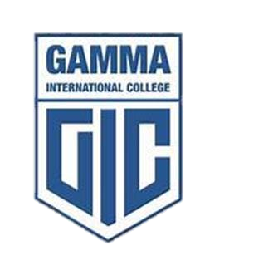

PYP 4 Supply list

Essential classroom Item | Quantity
Pencil case | 1
2B Pencils  Blue pens | 1 pack of 12  2
Erasers (Faber Castle) | 4
Sharpeners with containers | 2
Hard, clear plastic ruler (30 CM only) | 1
Highlighters | 1 yellow and 1 green and 1 pink
Wooden colored pencils (good quality) | 1 pack of 12
A4 colored Canson sheets | 3 packs of 10
A4 colored paper | 1 pack
A4 white paper | 1 pack
Window chart | 1
white charts  colored charts | 2  2
6 white board markers | 2 blue, 2 black, 2 green
Good quality white board (A4 size) | 1
Whiteboard duster | 1
Small glue sticks | 5
Metal scissor of good quality | 1
3 Display files (100 sheets) | 1
U-shape files (100) | 1 pack
Zip files A3 size | 1 white , 1 blue,  1 yellow ,1 black ,1 green ,1 orange
Bingo play dough (different colors) | 1
Clay | 1
English Big ring white binder for portfolio | 1
Science blue binder for portfolio | 1
English Social yellow binder for portfolio | 1
Arabic black binder for portfolio | 1
Arabic social studies green binder for portfolio. | 1
Math orange binder | 1
Big lines sticky notes | 1
Music copybook | 1
English double line copybooks  Social copybook  Science copybook  Math big squares book | 3  1  1  1
Big A4 Arabic copybook (lined) 60 sheets  Big A4 Arabic social studies copybook  (lined) 60 sheets | 1  1
Hygiene
Packs of tissue (550) | 3 packs
Wipes (200) | 2 packs
Alcohol | 1 L
PYP 4 Art supplies
White canson sketch size A4 | 1
Apron with long sleeves | 1
Colored canson sketch size A4 | 1
Pencil colors (24 pencils) | 1 pack
Flow master colors (24 pencils) | 1 pack
Watercolors palette | 1
Small scissors | 1
White glue | 1
Foam play dough | 1 pack
Tongue depressors |  | 1 pack

Paint brushes | Size 4&8
String rollers any color | 2
Canva 25*30 | 1
Zipper file | 1
Pencil case containing (pencils, eraser sharpener, large glue stick, black permanent marker)


- All supplies must be labeled with the child’s name.
- All art supplies should be placed
in the zip file.

